Dates of the conference
26-28 September, 2017

Place of event: South Kazakhstan State
Pharmaceutical Academy
Program:
- September – arrival the partners of the project
——————————————————————–
- September
9:00 - 9:30 – registration of participants
9:30 - 11:00 – opening and plenary session
11:00 - 11:20 – coffee break
11:20 - 13:00 – plenary session
13:00 - 14:00 – lunch
14:00 - 15:30 – plenary session
15:30 - 15:45 – coffee break
15:45 - 17:00 – plenary session
17:00 - 17:15 – summary of day

- September
———————————————————–———
9:00 - 10:45 – parallel sectional meetings
10:45 - 11:00 – coffee break
11:00 - 13:00 – parallel sectional meetings
13:00 - 14:00 – lunch
14:00 - 14:45 – summary and conclude(close) the
conference
departure of partners of the project
Address of conference:
South Kazakhstan region, Shymkent city, Al-Farabi square, 1
Tel: +7 7252408219
Kazakhstan:
+77013499366 – A.A.Akhmetova
+77078962249 – A.Ibragimova
+77029307711 – E.Orynbasarov

Uzbekistan:
+998 (91) 6605958 – A.R.Yunusov
+998 (90) 1865643 – D.T.Kaumova
+998 (90) 9344885 – S.A.Ubaidullayeva
+998 (90) 5610839 - K.B.Sattarova

e-mail: modehed.conf­2017@mail.ru web-site: www.modehed.uz
Organizing Committee

Requirement for articles:
- Admission of articles before July 25, 2017, it is optimal date for authors to receive the Conference Proceedings prepared by September 26-28
- Content should be up to 3 pages, A4 format, indent on all sides - 2.5 cm, font size-12 size, Times New Roman, interval - 1.5.
- Articles are accepted in Kazakh, Uzbek, Russian, and English languages. An abstract (300 characters) must be attached to the article in russian
- The title of the article is located in the center, full name of author, academic degree, place of work, e-mail address are indicated through the line.
- Tables and diagrams are printed in 10-point font in Microsoft Excel (Office 2003, 2007, 2010).
- The article must contain the methodology and problems of modernizing training courses on health in universities.
- The selection of articles is carried out by the editorial board in accordance with the criteria that developed in the project.
- Articles are accepted only in electronic form at the address modehed.conf-2017@mail.ru
- Authors of articles involved in the program must prepare a PowerPoint presentation (Office 2003, 2007, 2010).
- Travel expenses and accommodation costs for participants from partner universities of the project are paid from the project budget

Ministry of Health of Republic of Kazakhstan
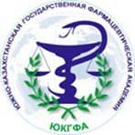

South Kazakhstan State Pharmaceutical Academy

International scientific and practical conference

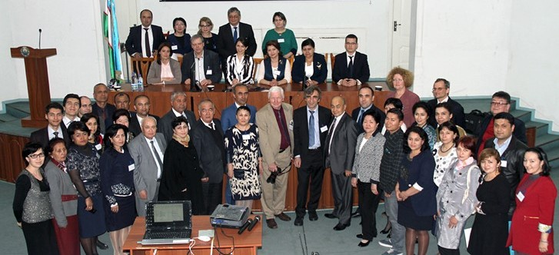

Within the framework of ERASMUS+ project

ModeHEd – Modernizing Health Education in Universities
Shymkent - 2017

“ModeHEd – Modernizing Health Education in Universities” (2015-2018)

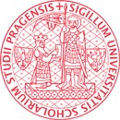
Parners of the project

The purpose of international scientific and practical conference:

  - Assisting the health state and improving public health by modernizing training courses on health in universities in Uzbekistan and Kazakhstan..
P1 |  | Hochschule fur  Technik Wirtschaft und Kultur Leipzig, HTWK (Leipzig, Germany) |  | P2 |  | Charles University in Prague, CUNI (Praha, Czech Republic)
P3 |  | Pavol Jozef Šafárik University in Košice, UPJS (Kosice, Slovakia) |  | P4 |  | Ferghana State University, FSU (Ferghana, Uzbeki­ stan)
P5 | 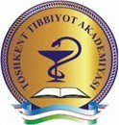 | Tashkent Medical Academy, TMA (Tashkent, Uzbeki­ stan) |  | P6 | 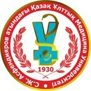 | S.D.Asfendiyarov Kazakh National Medical University, KazNMU (Almaty, Kazakhstan)
P7 |  | Namangan State University, NSU (Namangan, Uzbek­ istan) |  | P8 |  | The Center of the Development of the medical education, CDMEdMPH  (Tashkent, Uzbeki­ stan)
P9 |  | Uzbek State Insti­ tute of Physical Culture, UzSIPhC (Tashkent, Uzbeki­ stan) |  | P10 | 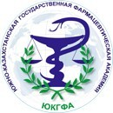 | South Kazakhstan State Pharmaceuti­ cal Academy, SKSPhA  (Shymkent, Ka­ zakhstan)
P11 |  | Bukhara State Medical Institute, BSMI (Bukhara, Uzbekistan) |  | P12 |  | Kazakh state wom­ en's teacher training university, KSWTU (Almaty, Kazakh­ stan)
P13 |  | Andijan State University, AndSU (Andijan, Uzbeki­ stan) |  | P14 |  | Kokand State Pedagogical insti­ tute, KSPI (Kokand, Uzbeki­ stan)
 |  | P15 |  | Uzbek Medical- Pedagogical Association, UzMPA  (Tashkent, Uz­ bekistan)

The objective of international scientific and practical conference:

  - Studying the states of methodological courses on healthcare in universities;
  - Studying the best experience of European universities to develop and modernize methodological courses;
  - Development of multimedia segment of 8 methodological courses on health care;
Improvement of curriculum complexes on the basis of upgraded methodological courses.

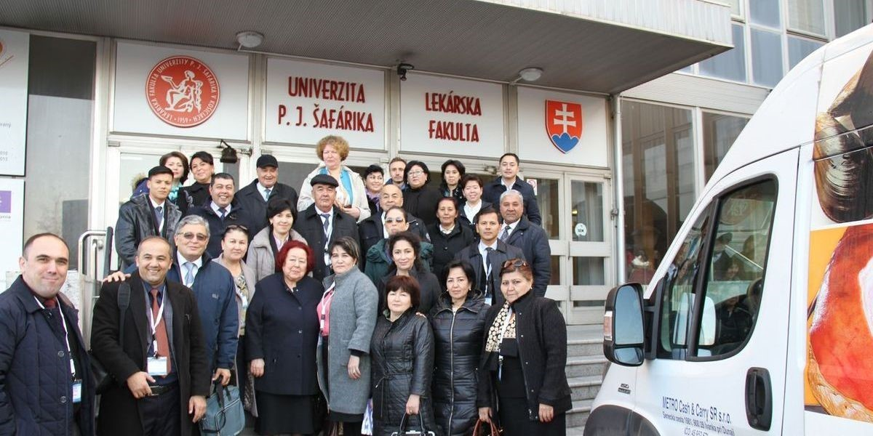
Theme of sectional sessions:

Section 1:
  - Issues on effective modernization of training courses - Valeology, Fundamentals of Medical Knowledge, Age Physiology and Hygiene, Physiology;
For KazNMU - Physiology
Section 2:

  - Modernization of training courses problems - Sports medicine and hygiene of physical culture, Physical training and hygiene of physical culture;
Section 3:

  - Modernization Course - pre-hospital emergency medical care;
Section 4:

  - Problems of modernization course - Public health and management of public health

Section 5:
  - Development of inter-project relations and studying the experience of related projects, such as UzHealth, TechReh, MEDiPHyS, SPHERA, TAME

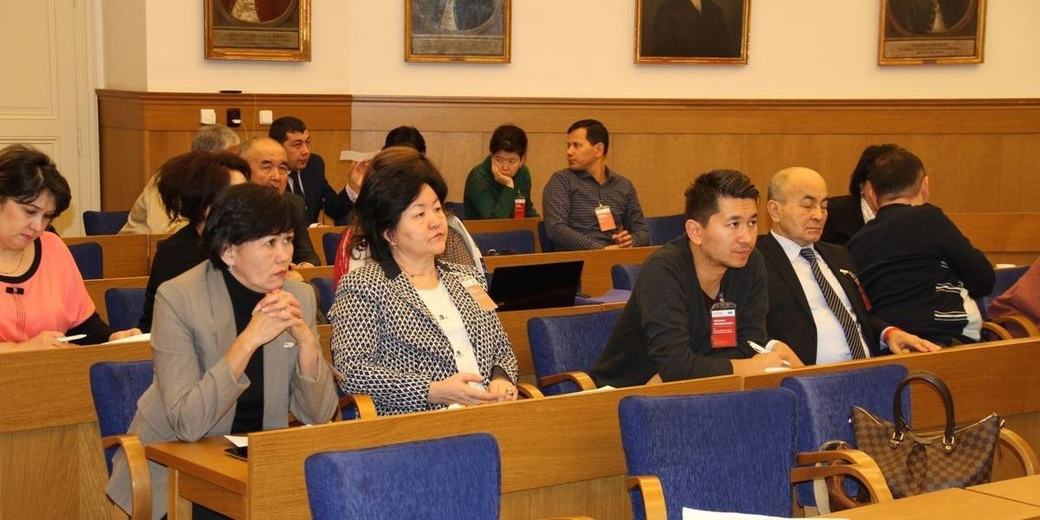
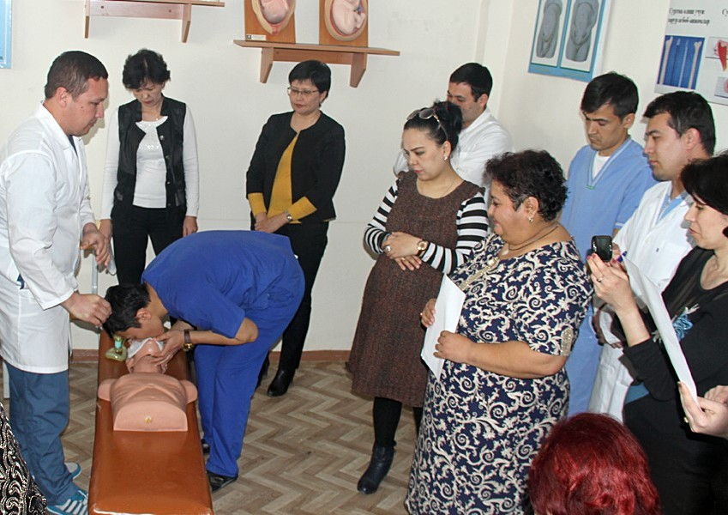

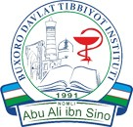

International scientific and practical conference of “ModeHEd – Modernizing Health Education in Universities” is financed by the ERASMUS + program of the European Union

