Orynbassarov Yerzhan Kassymkhanovich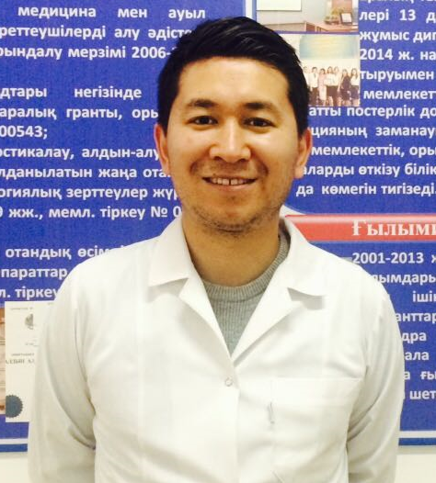
Master of Pharmacy
Phone: +7(702)930-77-11
Email: orynbasar_yerzh@mail.ru

Background:
Higher education – South Kazakhstan State Medical Academy, pharmacy (specialist);
South Kazakhstan State Pharmaceutical Academy, pharmacy (master’s degree);
University of International Business, marketing (bachelor’s degree);
Academic Innovation University, two foreign languages (bachelor’s degree)

Internships:
Gdansk Medical University (Poland), pharmacy (master’s degree)
University of Pharmaceutical and Veterinary Sciences in Brno (Czech Republic), supervision of students

Honors:
Master of Pharmacy, senior lecturer, department of pharmaceutical and toxicological chemistry, SKSPhA

Researching activity: more than 10 scientific publications, co-author of more than 15 books, handbooks and methodical recomendations

Teaching activity: Pharmaceutical chemistry, General methods of drug analysis, Drug standardization and metrology.

Teaching experience: 8 years

Yerzhan Orynbassarov is a senior lecturer at the department of Pharmaceutical and Toxicological Chemistry, SKSPhA. He teaches the subjects of Pharmaceutical chemistry, General methods of drug analysis, Drug standardization and metrology in Kazakh, Russian and English. The classes taught by Dr. Orynbassarov are informative and catching. He also has rich experience at organizing international cooperation.
Dr. Orynbassarov is a member of SKSPhA team in ERASMUS+ JP – ModeHEd (2015-2018) project. Responsible for technical and organizational activitirs of the project.

