Ibragimova Aygul Gaffarovna
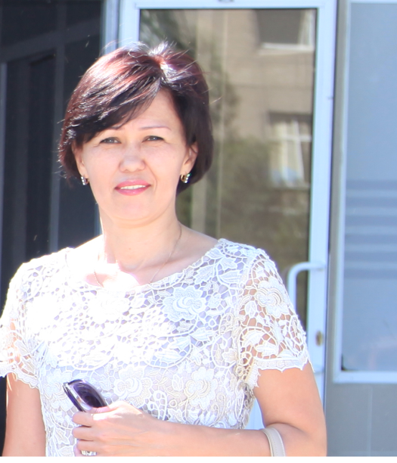

The Head of curriculum center of JSC “South Kazakhstan State Pharmaceutical Academy”
Mobile number: +7(701) 406 52 31
Email: aygul_ibr@mail.ru

Education:
High education – South Kazakhstan State Pharmaceutical Academy, pharmacy (specialist 1985-1990);
South Kazakhstan State Pharmaceutical Academy, pharmacy (postgraduate 1992-1995 );
Scientific interests:
Rational using of medicines
Educational degree, title:
Candidate of pharmaceutical sciences, associate professor (docent) of pharmacology, pharmacotherapy and clinical pharmacology department
Research work: More than 50 scientific publications, textbooks, tutorials
Activities as a teacher: Pharmacology, pharmacotherapy, rationale using of medicines, pharmaceutical care
Pedagogical experience: more than 20 years

Ibragimova Aygul Gaffarovna is working as the Head of curriculum center of SKSPhA since 2013.
The main directed activities of organizing the curriculum proccess is:
- To develop normative documentation that regulating educational proccess;
- To develop the curriculum plans, timetables and academic calendars;
- Staffing;
- Monitoring of imlementation of modern educational technologies;
- To support for curriculum proccess;
- Organizing and monitoring of professional practice;
- Refresher courses of teaching staff etc.
Has experience on conducting accreditation (institutional and specialized), expert evaluation of educational programmes of universities (member of Kazakhstani agency on ensuring the quality of education expert group), has experience on participating in strategic partnership with foreign country universities, experience on developing the academy’s strategy, plan of development, has experience on developing scientific projects in searching, developing and researching medicines (drugs).

Member of SKSPhA team in Erasmus+ JP – ModeHEd (2015-2018) project
Responsible for developing the plans and content of modernized disciplines.

