Alma Akhmetova
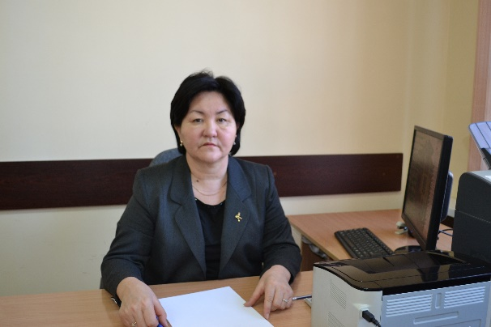
Vice-rector for strategic partnership and international cooperation of South Kazakhstan state pharmaceutical academy
Phone: +7(701)349-93-66
Email: alma_ukgfa@mail.ru
Education:
Higher –Kazakh National University, specialty «Chemistry»;
South Kazakhstan state medical academy, specialty «Pharmacy».
Scientific traineeship:
Copenhagen (Denmark);
Medical university of Gdansk (Poland).
Academic degree, academic title:
PhD in chemical sciences (Cand.Chem.), associate Proffesor
Research work: More than publications of scientific and methodical nature, co-author of over 10 books and methodical recommendations.
Teaching activity: Organic chemistry, chemistry of natural compounds, synthesis of biologically active compounds.
Teaching experience: 35 years

Alma Akhmetova is a vice-rector for strategic development and international cooperation. Cooridinates the strategic partnership of Academy with foreign universities, the issues of institutional and specialized accreditation of study programs, academic mobility of students and faculty, qualification improvement of academic staff.
In different years she had headed the training and methodical center of the university, had been a vice-rector for development and innovation.
She has a great experience in organizational work (responsible secretary of Admission Committee, scientific secretary of the university).
She is an expert of Independent Kazakhstan Agency for quality assurance in education (IQAA).
She is a member of SKSPhA team in ERASMUS+ JP–ModeHEd (2015-2018), the Local coordinator in Kazakhstan.

