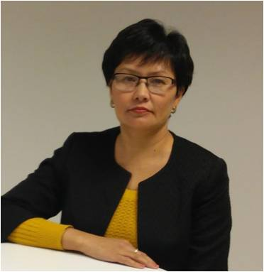 | SEIDAKHMETOVA AIZAT  The developer of the program: "Improving the best practices in the provision of the first pre-medical care"
Date of Birth | 9.10.1970
Nationality | Kazakh
Academic degree (specialization code) | Candidate of Medical Sciences (14.00.05-internal diseases)
Position, organization of education (place of work) | Head of the Department of Nursing with the course of anesthesiology and resuscitation of the South Kazakhstan State Pharmaceutical Academy
Address of educational organization (e. E-mail, phone, fax Chancellery) | Kazakhstan, Shymkent, Al-Farabi sq. 1  (medacadem@rambler.ru, 8-7252-40-82-22)
Home address | Shymkent, Al-Farabi sq. 3 a - 26
Work phone | 8-7252-40-82-22
Mobile phone | 87017671448
e-mail | aizat-seidahmetova@mail.ru
Identification | № 038438569
Passport | № 08748522
Education
1987-1993 | The Faculty of Medicine of the Karaganda State Medical Institute
Medical qualification category
Therapist | supreme
Publications | More than 100 scientific works, including -  Pre-patent for the invention, 6 teaching aids, co-author of 2 standard programs and clinical cases for the specialty "General Medicine", "Nursing".
Member of the commission | - Working Committee of the National Commission for the Development of the Nursing Education System  - Working Group and the coach of the project "Development and implementation of medical ethics program development and communication skills of health professionals"  - Internal quality control  - Chairman of the Cyclic Methodological Commission of Clinical Disciplines  - Adviser specialty "Nursing"
Advanced training | - Fundamentals of Medical Education, Astana  - Almaty State Institute of Improvement of Doctors "Teacher of Medical Organizations of Education and Science"  - Communication skills, Kazakh National Medical University of Almaty  - Introduction of a credit training system, South Kazakhstan State Pharmaceutical Academy Shymkent  - Competence approach in the development of educational programs, International Kazakh-Turkish University of Turkestan  - Fundamentals of Evidence-Based Medicine, Republican Center for Health Development  - Techniques for designing test tasks, National Testing Center of Astana  - "Model of training of specialists in nursing in Finland"  - "Reforming the educational standard of academic baccalaureate in the specialty of Nursing for Medical Universities"  - "Development of a flexible accelerated trajectory of teaching academic bachelor's degree in the field of Sisterhood"

